|  |  |  |  |
| --- | --- | --- | --- |
| VIIT Pune (@viit_pune) | Twitter | Bansilal Ramnath Agarwal Charitable Trust's  Vishwakarma Institute of Information Technology  **Department of**  **Artificial Intelligence and Data Science** | | |
| Student Name: Sakshi Vijay Darandale | | | |
| Class: TY | Division: A | | Roll No: 371017 |
| Semester: 5th | | Academic Year: 2022-23 | |
| Subject Name & Code: Cloud Computing and Analytics | | | |
| Title of Assignment: Assignment- 4 Study & Implementation of identity management. | | | |
| Date of Performance: 01/12/2022 | | Date of Submission:02/12/2022 | |

Aim: Study & Implementation of identity management.

Problem Statement: Study & Implementation of identity management.

Background Information:

**Identity management** (IdM), also known as identity and access management (IAM) ensures that authorized people – and only authorized people – have access to the technology resources they need to perform their job functions. It includes polices and technologies that encompass an organization-wide process to properly identify, authenticate, and authorize people, groups of people, or software applications through attributes including user access rights and restrictions based on their identities.

An identity management system prevents unauthorized access to systems and resources, helps prevent exfiltration of enterprise or protected data, and raises alerts and alarms when access attempts are made by unauthorized personnel or programs, whether from inside or outside the enterprise perimeter.

Identity management solutions not only protect software and data access, they also protect the hardware resources in an enterprise, such as servers, networks, and storage devices from unauthorized access which could lead to a [ransomware](https://www.vmware.com/topics/glossary/content/ransomware.html) attack. Identity management has gained importance over the past decade due to the growing number of global regulatory, compliance, and governance mandates that seek to protect sensitive data from exposure of any kind.

IdM and IAM systems generally are part of IT security and IT Data management within the enterprise, and identity and access management tools are widely available for the broad range of devices that users rely on to perform business functions from phones and tablets to desktop computers running Windows, Linux, iOS or Android.

IdM and IAM are terms often used interchangeably, however identity management is more focused on a user identity (or username), and the roles, permissions, and groups that user belongs to. IdM also focuses on protecting identities through a variety of technologies such as passwords, biometrics, multi-factor authentication, and other digital identities. This is usually achieved by the adoption of identity management software applications and platforms.

Procedure:

Step 1: OwnCloud is open source file sync and share software for everyone from individuals operating the free ownCloud Server edition, to large enterprises and service providers operating the ownCloud Enterprise Subscription. ownCloud provides a safe, secure, and compliant file synchronization and sharing solution on servers that you control. You can share one or more files and folders on your computer, and synchronize them with your ownCloud server.

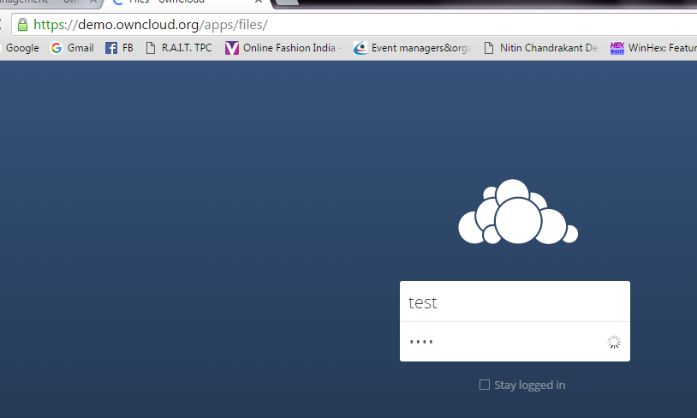

Step 2 : By default, the ownCloud Web interface opens to your Files page. You can add, remove, and share files, and make changes based on the access privileges set by you (if you are administering the server) or by your server administrator. You can access your ownCloud files with the ownCloud web interface and create, preview, edit, delete, share, and re-share files. Your ownCloud administrator has the option to disable these features, so if any of them are missing on your system ask your server administrator.

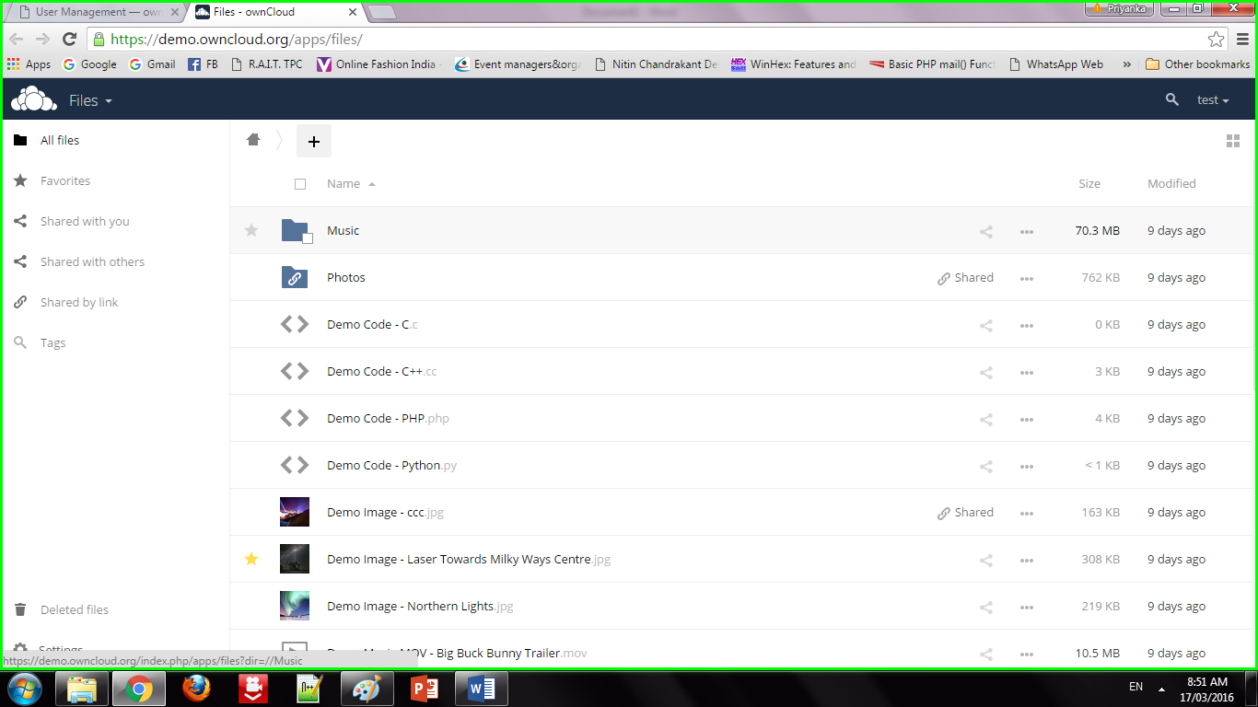

Step 3: **Apps Selection Menu:** Located in the upper left corner, click the arrow to open a dropdown menu to navigate to your various available apps. **Apps Information field:** Located in the left sidebar, this provides filters and tasks associated with your selected app. **Application View:** The main central field in the ownCloud user interface. This field displays the contents or user features of your selected app.

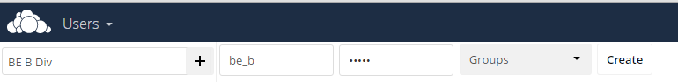

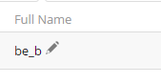

Step 4: Share the file or folder with a group or other users, and create public shares with hyperlinks. You can also see who you have shared with already, and revoke shares by clicking the trash can icon. If username auto-completion is enabled, when you start typing the user or group name ownCloud will automatically complete it for you. If your administrator has enabled email notifications, you can send an email notification of the new share from the sharing screen.

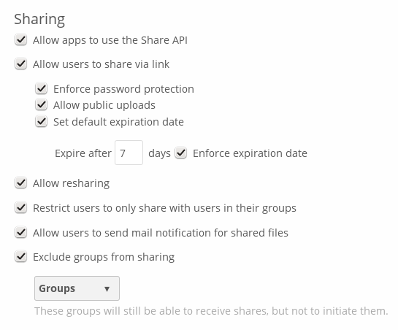

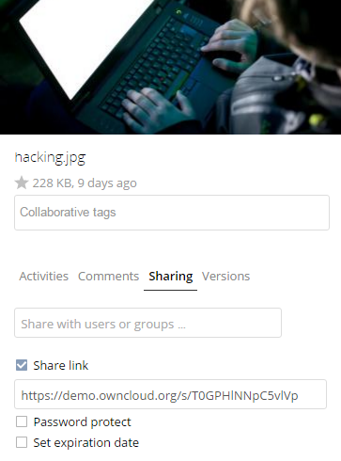

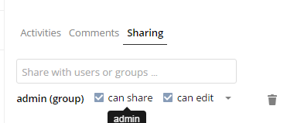

Step 5: Five Share permissions are :

Can share; allows the users you share with to re-share.

Can edit; allows the users you share with to edit your shared files, and to collaborate using the Documents app.

Create; allows the users you share with to create new files and add them to the share.

Change; allows uploading a new version of a shared file and replacing it.

Delete; allows the users you share with to delete shared files.

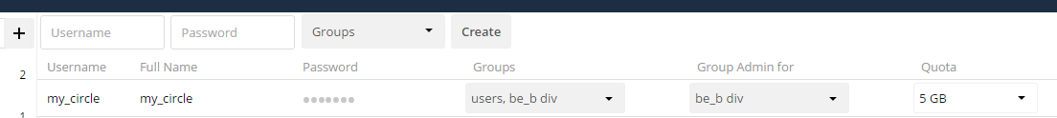



GitHub Repo Link:

[**https://github.com/Sakshid18/Cloud-Computing-and-Analysis**](https://github.com/Sakshid18/Cloud-Computing-and-Analysis)

Conclusion: We have studied how to use ownCloud for ensuring identity management of the users. We can create multiple groups and provide privileges to view or modify data as per defined permissions. It also enables simplified look and feel to be used by anyone.